Brussels, 20th May 2011
Under embargo: 17.40 Regulated Information

PRESS RELEASE

IMMOBEL SELLS A RETAIL PROJECT, LOCATED IN WAVRE, TO THE DECATHLON GROUP

Immobel and ANSIMMO have signed, today 20th May 2011, a sales deed for a new Decathlon shop in Wavre.

Decathlon will open a new retail surface of 4.400 m² on 25th May on a plot of land of 6 ha 26 a with a parking of over 400 places.

Immobel has been entrusted with the construction of the main structure of the building, the development of the parking and its near surroundings. The first stone was set on 15th December 2010.

The transaction amounts to approximately 12 MEUR.

Immobel has also built, in agreement with the Walloon Ministry of Equipment and Transports, a roundabout which, on the one hand, will allow access to the Decathlon shop and, on the other hand, will enhance the security at the intersection, an important connecting node (E411, N25, N4).

Gaëtan Piret, Managing Director of Immobel comments on the transaction as follows :

“The Landbanking department has realized on this site, initially destinated for a land development, an important retail project, supported by the official authorities of the City and Region. This project takes into account remarks formulated by the neighbours and has been delivered with respect of strict time delay.”

Herman Van Beveren, CEO of Decathlon in Belgium comments: « We are delighted of our partnership with Immobel. We are now in the position to offer a full service to our customers of Walloon Brabant, whilst respecting the environment and our neighbours.»

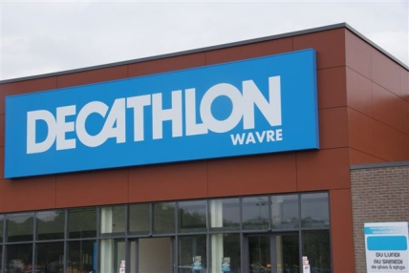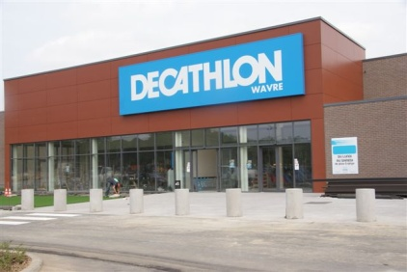

For further information:
Gaëtan PIRET*, Herman Van Beveren
CEO IMMOBEL CEO DECATHLON Belgium
T: +32 (0)2 422 53 23* sprl T: +32 (0)3 546 41 93
gaetan.piret@immobel.be Herman.vanbeveren@decathlon.com

About IMMOBEL:

IMMOBEL has, for 145 years, been an undisputed player in property development in Belgium. Its business covers the offices,
residential, land sectors, thus enabling it to diversify its project portfolio. It is also active in Belgium, Grand Duchy of Luxembourg and Poland. Its vision of the market and its expertise mean it can design, manage and sponsor ambitious property projects, making for added value in the long term, in keeping with the surrounding area and incorporating major corporate imperatives.

IMMOBEL is listed on Euronext Brussels as “IMMOBEL”.
For further information see : www.immobel.be.

About Decathlon
Decathlon is part of the Oxylane group and its mission is “to encourage sports and to make the pleasures and fun of sports available to as many people as possible”. This is achieved by making sports reasonably priced (low prices), with an enduring guarantee on product quality, and by offering a big range of products (65 sports under one roof). Decathlon manufactures and sells sports goods and brands (own brands – the passion brands like Quechua, Tribord, Inesis and Kipsta – as well as other international brands). Decathlon is active in sales in Belgium since 1997 (first store in Antwerp) and currently owns 11 points of sale and a logistics centre, employing more than 1,600 people.

